ADDITIONAL HANDSON :
REACT-13
Objectives

- Explain various ways of conditional rendering
The various ways of using Conditional rendering are:
Using If-Else,Ternary Operator,Using logical operator
- Explain how to render multiple components
We can render multiple components inside a parent component using JSX.
- Define list component
A list component displays a list of items using the map() function.
- Explain about keys in React applications
Keys are unique identifiers assigned to elements in a list. React uses them to identify which items changed, added, or removed

- Explain how to extract components with keys
We can extract a list item into a separate component and still use key in the parent list:
- Explain React Map, map() function
The map() function in React is used to loop over arrays and return JSX for each item.

In this hands-on lab, you will learn how to:
- Implement conditional rendering in React applications

Prerequisites

The following is required to complete this hands-on lab:
- Node.js
- NPM
- Visual Studio Code

Notes

Estimated time to complete this lab: 60 minutes.
Create a React App named “bloggerapp” in with 3 components.

- Book Details.js
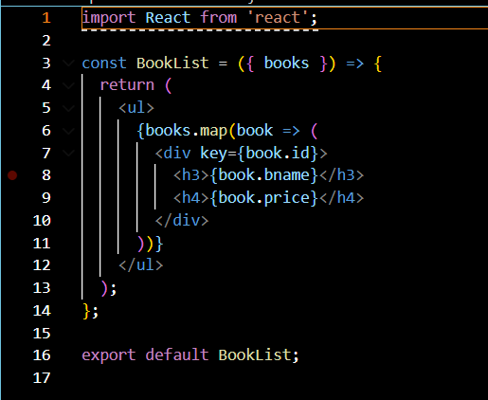
- Blog Details
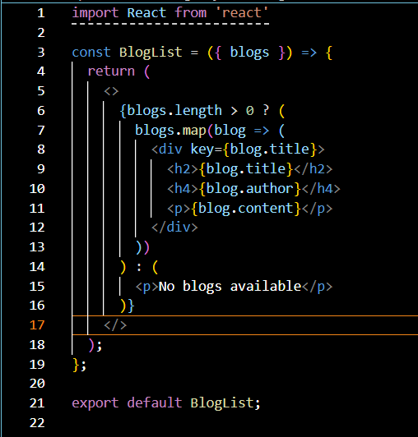
- Course Details
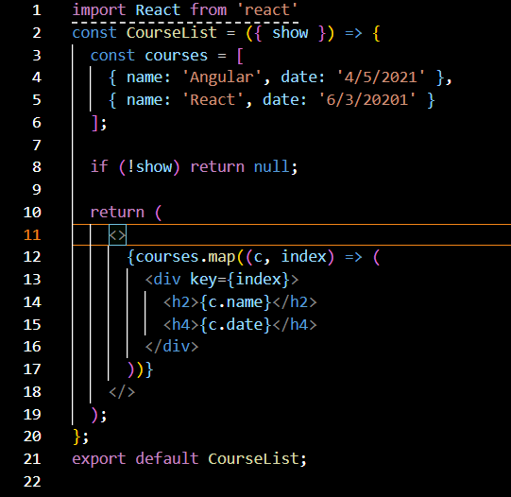

OUTPUT:

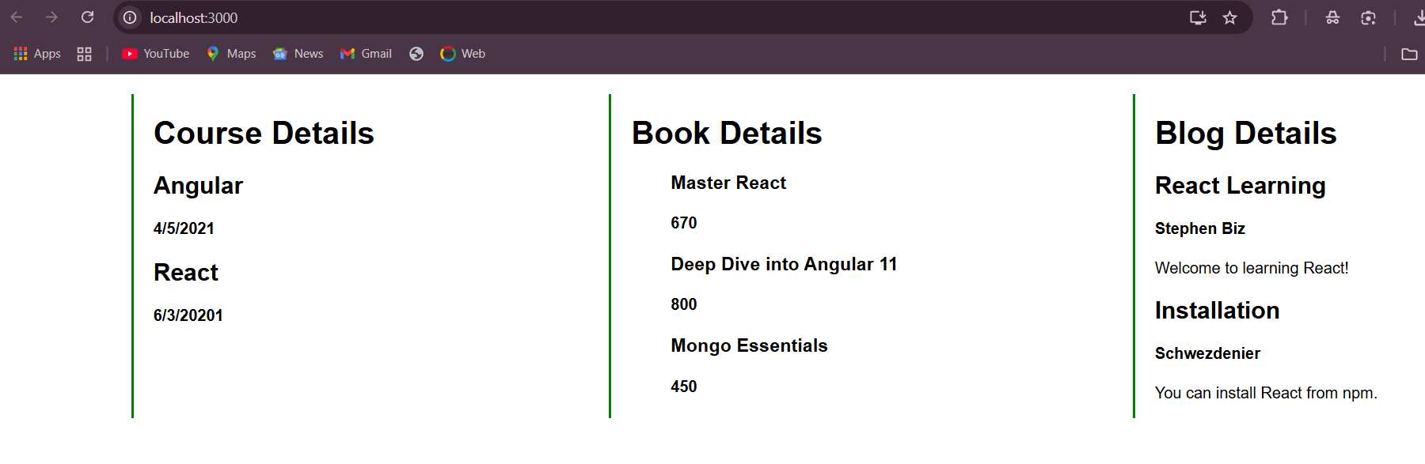

REACT-14
Objectives
- Explain the need and Benefits of React Context API
In React, props are used to pass data from one component to another (parent → child). But if we have deeply nested components, we have to pass props through multiple levels — even if intermediate components don’t need the data. This is called prop drilling.
- Working with createContext()
React provides a function called createContext() to create a Context object.
- List the types of Router Components
The types of routerComponents include: BrowserRouter,Link,Routes,NVLINK.

In this hands-on lab, you will learn how to:
- Create a context to be used by child components
- Create a provider and consumer of the context
Prerequisites

The following is required to complete this hands-on lab:
- Node.js
- NPM
- Visual Studio Code

Notes

Estimated time to complete this lab: 30 minutes.

Developers of Apps Centric Solutions have created an employee management application which supports light and dark themes for the buttons. The current solution uses the react state and props to provide the theme name to be used from App component to Employee List component and from there to Employee Card component. Quality assurance team analyzed the solutions and found the technique being used to be a substandard one. React architect suggested to use the react context API to share the theme name with nested child components instead of passing them down using props from the parent component.
You are assigned the task of converting the application form props only to React Context API.
Application can be downloaded from below
- Unzip the application and open it using VS Code
- Go to terminal and execute npm install command to restore all the node modules
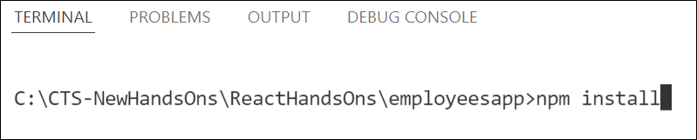
Figure 1: Restore node modules
- Run the application once to see the output. Use npm start command.
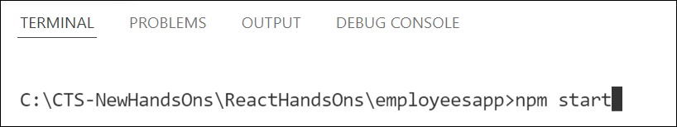
Figure 2: Starting application
- Explore the components present in App.js, EmployeesList.js and EmployeeCard.js files.
- Create a new file with the name as ThemeContext.js. Define a new context in the file with the name as ThemeContext and assign it a default value of ‘light’ and export it as default form the module.
- Open App component present in App.js file.
  - Import the ThemeContext in App component.
  - Define the theme context provider to be the entire JSX of the App component.
  - Assign the value for the theme provider from the state of the component.
  - Modify the call to EmployeeList component so that theme name is no longer passed as props.
- Go to EmployeeList component present in EmployeeList.js file and modify it so that theme name is not passed explicitly to its child component.
- Go to EmployeeCard component inside EmployeeCard.js file
  - Import the ThemeContext into the component file
  - Retrieve the value of the context with the help of useContext() and store it in a variable
  - Use the variable to pass the className for the buttons.

Output:
Deafult theme is light

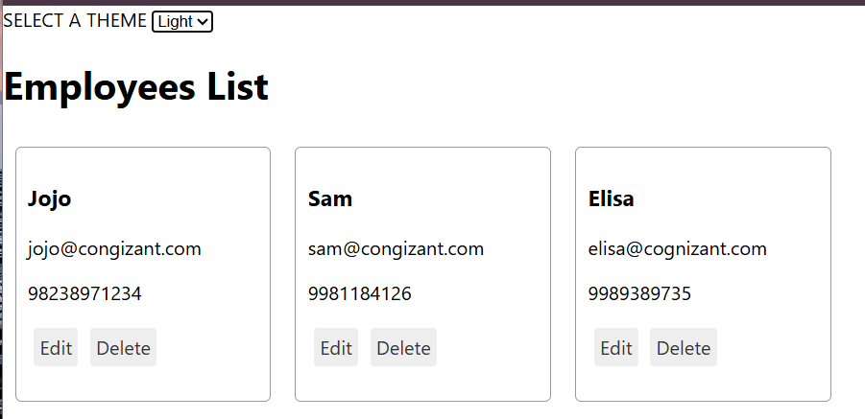
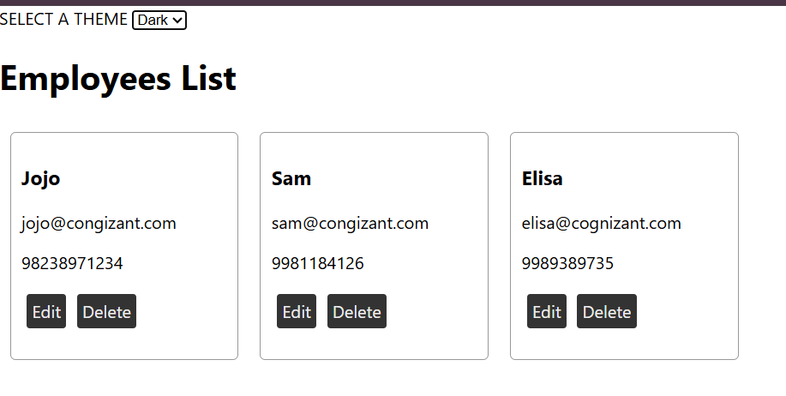

REACT-15
Objectives

- Explain about React forms
In React, forms are used to collect user input. Unlike traditional HTML forms that directly manage the input, React forms are usually controlled using component state. This makes the form fields dynamic and interactive.
- Define controlled components
A controlled component is a form element (like <input>, <textarea>, or <select>) whose value is controlled by React state.
- Explain about various input controls
React supports various html input controls like:
Input, textarea, select, checkbox, radio, etc.
- Explain about handling forms
Uses onChange to update state
- Explain about submitting forms
Uses an onSubmit handler to process the form.
In this hands-on lab, you will learn how to:
- Implement React forms
- Use various input controls like textbox, button and textarea

Prerequisites

The following is required to complete this hands-on lab:
- Node.js
- NPM
- Visual Studio Code

Notes

Estimated time to complete this lab: 60 minutes.
Create a React App named “ticketraisingapp” which will help to raise a complaint and get it resolved.

Create a component named “ComplaintRegister” with a form containing a textbox to enter the employee name and a textarea to enter the complaint. Use “handleSubmit” event of the button to submit the complaint and generate a Reference number for further follow ups in the alert box.
ComplaintRegister.js
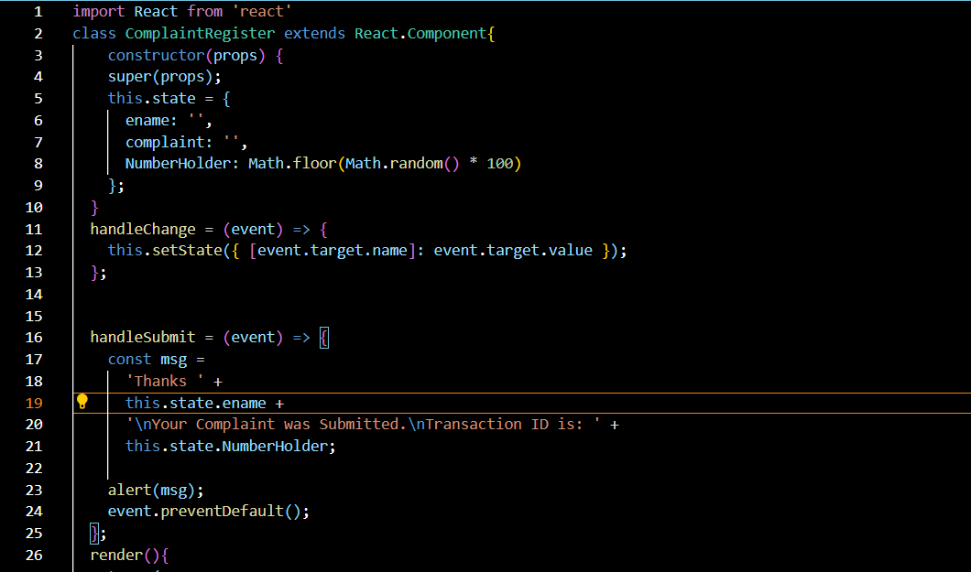
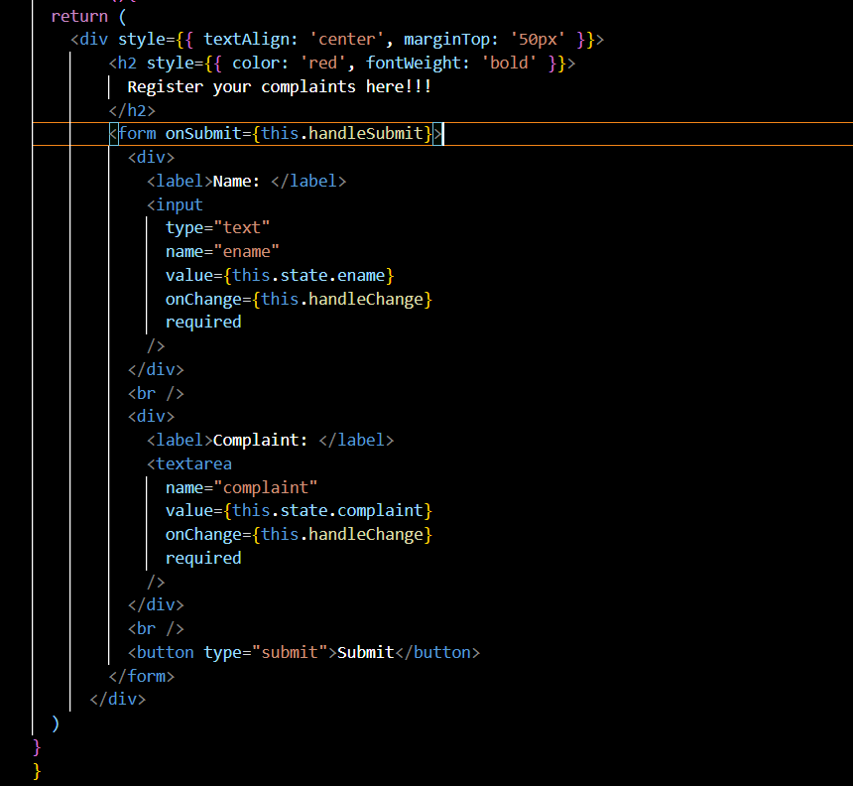
App.js
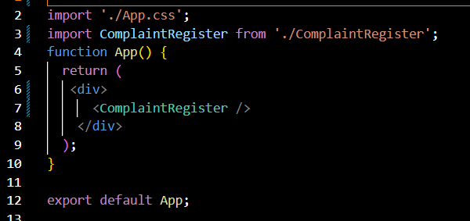

Output:
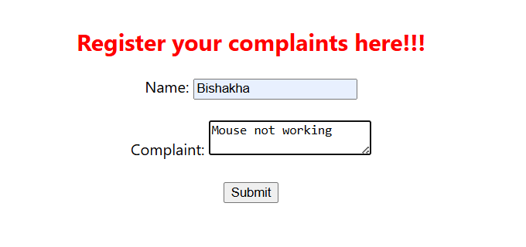

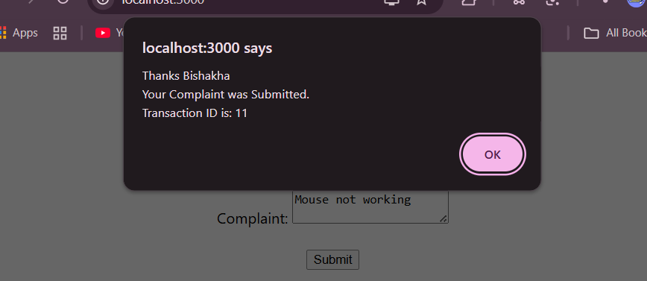

REACT-16
Objectives

- Explain about React forms
In React, forms are used to collect user input. Unlike traditional HTML forms that directly manage the input, React forms are usually controlled using component state. This makes the form fields dynamic and interactive.
- Define controlled components
A controlled component is a form element (like <input>, <textarea>, or <select>) whose value is controlled by React state.
- Explain about various input controls
React supports various html input controls like:
Input, textarea, select, checkbox, radio, etc.
- Explain about handling forms
Uses onChange to update state
- Explain about submitting forms
Uses an onSubmit handler to process the form.

In this hands-on lab, you will learn how to:
- Implement React forms validation
- Use various input controls like textbox, button and textarea

Prerequisites

The following is required to complete this hands-on lab:
- Node.js
- NPM
- Visual Studio Code

Notes

Estimated time to complete this lab: 60 minutes.
Create a React App named “mailregisterapp” which will have a component named “register.js”. Create a form which accepts the name, email and password and validate the fields as per the following:

- Name should have atleast 5 characters
- Email should have @ and .
- Password should have atleast 8 characters.

Ensure that validations are implemented through eventhandle and eventsubmit of a form.

Register.js
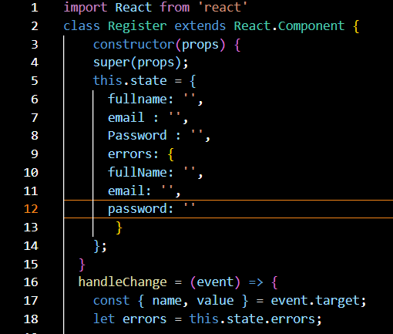
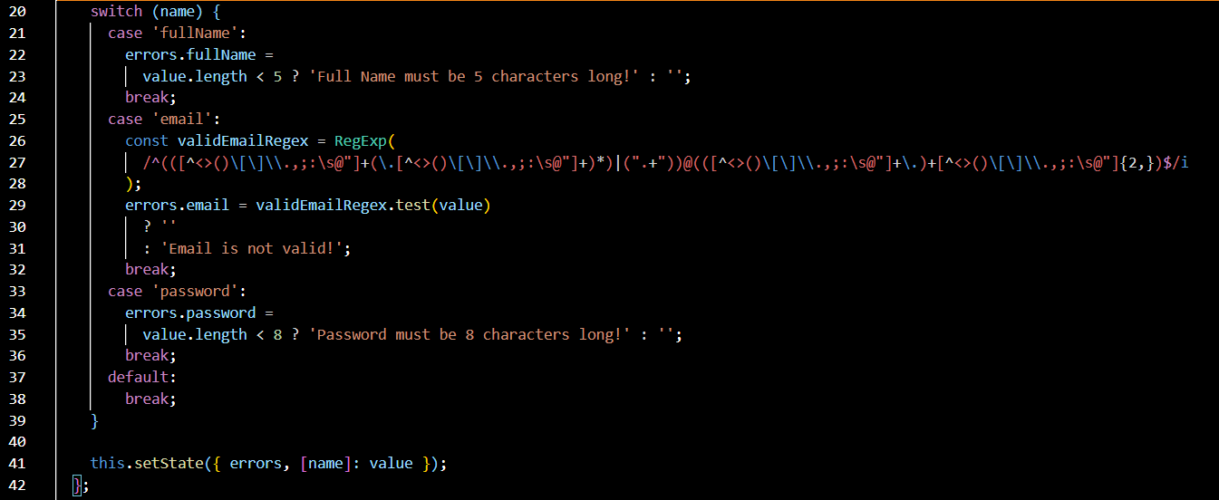
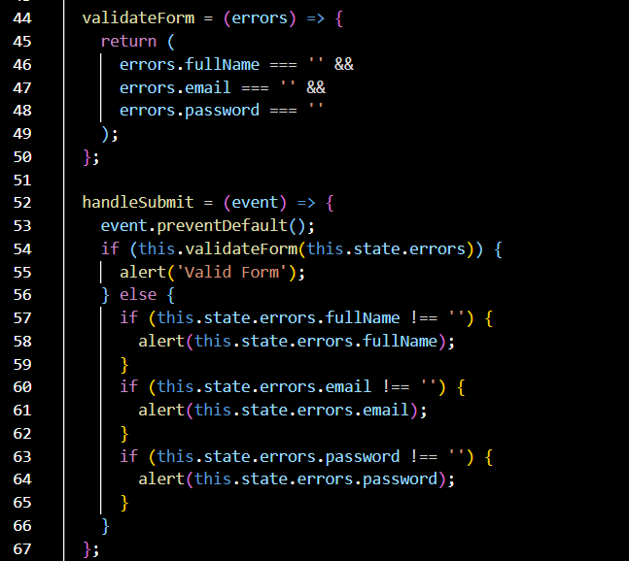
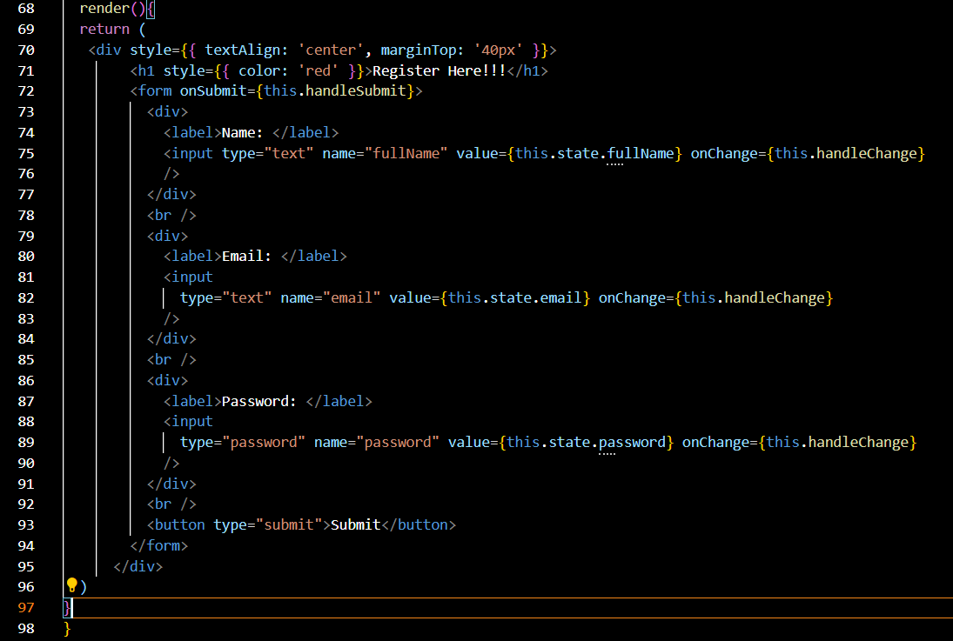

Output :
